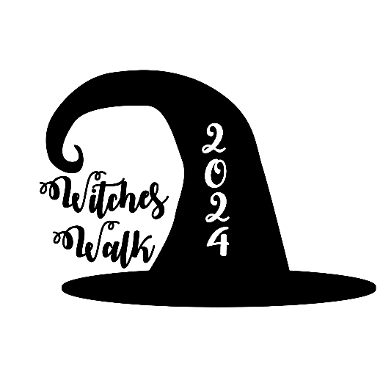

We would like to participate in the 2024 Witches Walk.

Business Name: ______________________________________  
Contact Number: _____________________________________  
Contact Name:_______________________________________  
Email: ______________________________________________

Address of Business:___________________________________

Type of Store:___________________________

Special offer or gift you will be giving away that night: (this will be listed in the welcome packet)

­­­­­­­­­­­­­-------------------------------------------------------------------------------------------------------------------------------

Yes, I would like to donate a $_________ gift certificate to my store to be given away in the drawing at 8pm.

Please return this form to:  
Maria Geppert  
1701 Washington Street  
Highland, Il 62249  
  
or email the information to mariaemarsh11@yahoo.com  
913-645-8379  
  
Gift Certificates will be collected prior to the event.