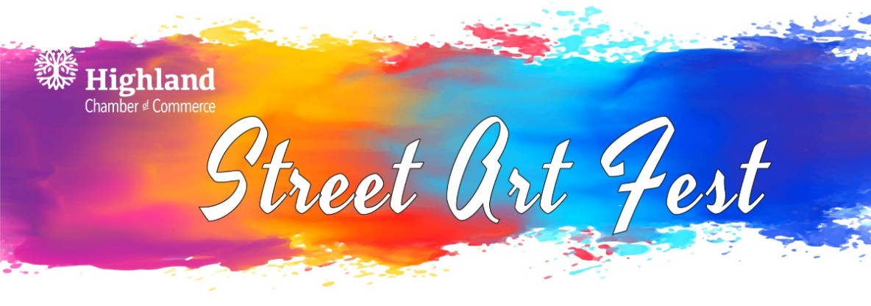
The annual Street Art Festival featuring a Makers Market, Kids Korner, Entertainment and Food/Drink will be held on Saturday, Sept. 21st (Sept. 22nd rain date). The streets of downtown Highland will once again become a temporary art gallery as artists transform the pavement into colorful works of art. We invite you to express your support of the arts and our community by being a part of this unique experience!

The Street Art Festival is the perfect way to showcase a business or organization. Your sponsorship helps promote your business/organization and helps the Chamber provide quality events in Highland that everyone can enjoy!
STREET ART SPONSORSHIPS

*Event Sponsor $750
Company name included in:
- Logo on back of artist’s t-shirts
- Signage at event
- Name featured on website and online social media
- Recognition in the Chamber E-newsletter

ART SQUARE SPONSORSHIPS
You may Co-Sponsor with another business and share the cost! Just indicate your Co-Sponsor on your Art Square Sponsorship Form.

*Michelangelo Level - $1,000
- 100 Sq. Ft. art square created by a street artist
- Name displayed next to the street art square
- Name featured on website and online social media
- Recognition in the Chamber E-newsletter

*Da Vinci Level - $500
- 65 Sq. Ft. art square created by a street artist
- Name displayed next to the street art square
- Name featured on website and online social media
- Recognition in the Chamber E-newsletter

*Monet Level - $250
- 40 Sq. Ft. art square created by a street artist
- Name displayed next to the street art square
- Name featured on website and online social media
- Recognition in the Chamber E-newsletter

*You do not have to supply your own artist, if you do not have one, we will supply an artist for you!

Please see the reverse side for the Sponsorship Form.

Thank you for your support!!!

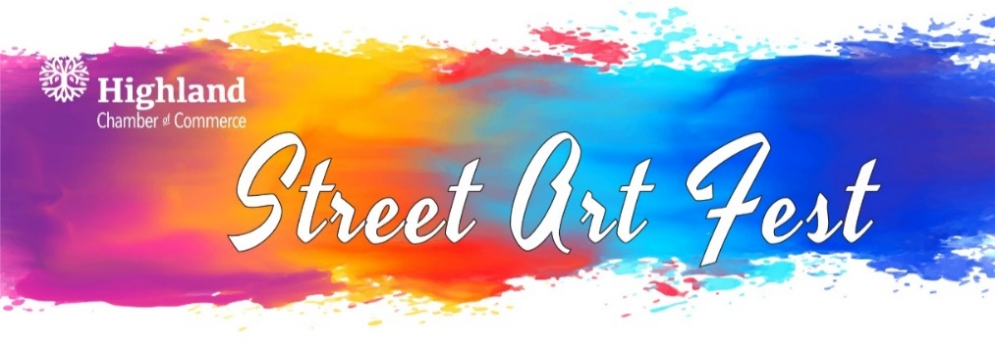
Thank you for choosing to support the Street Art Festival! Please choose your desired sponsorship from the list below:

Event Sponsorship

$750 Sponsorship

Square Sponsorship

$1,000 Michelangelo (100 sq. ft.) $500 Da Vinci (65 sq. ft.) $250 Monet (40 sq ft.)

We will provide our own artist(s). (Please provide artist’s name and contact information.)

- We need assistance with acquiring an artist.

Company/Organization:
(Please indicate name(s) of company/organization as you would like to have it printed in our advertising.)

Contact:
Address:
City / State / Zip:
Phone: Email: ___________
Please send completed sponsorship form and payment to the Highland Chamber of Commerce
1216 Main Street, Highland, IL 62249 by August 10, 2024. Payments made be made by: cash, check, credit card or PayPal.Me/highlandchamber

The Street Art Festival committee and the Chamber cannot be held responsible for complications due to rain, other acts of nature including health crisis. *Rain date is September 22nd.

If you have any questions regarding the Street Art Festival, please call the Chamber office at
618-654-3721.

Thank you for supporting the Arts in Highland and the Mission of the Chamber to make
Highland the best place to Live, Learn, Work, Shop & Play!

