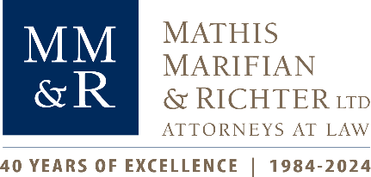 | Contact: Michael Embrich,  Director of Marketing & Business Development  Mathis, Marifian & Richter, Ltd.  Phone: (618) 234-9800, ext. 266  Email: membrich@mmrltd.com

FOR IMMEDIATE RELEASE:
Photos available.
Metro East Attorney Awarded for Outstanding Achievements
Mathis Recognized in Illinois for over 40 Years of Success Preserving Family Legacies

[Belleville, IL, June 26, 2024] – Patrick B. Mathis, a founding shareholder at Mathis, Marifian & Richter, Ltd., was recently honored as the recipient of the Outstanding Achievement in Estate Planning Award presented by the Illinois Institute for Continuing Legal Education (IICLE®). The annual award was announced at the IICLE® Estate Planning Short Course 2024 Seminar held on June 6, 2024 in Champaign, Illinois.
The Outstanding Achievement in Estate Planning Award by IICLE® recognizes the distinguished contributions and achievements of an Illinois attorney who embodies professionalism, innovation, and commitment within estate planning. This accolade symbolizes the significant influence Mathis has had in protecting and upholding the legacies of individuals, families, and communities for over four decades.
The award is bestowed annually upon an Illinois attorney who demonstrates exceptional proficiency in estate law, taxation, wealth preservation, and asset distribution. Their ability to create personalized estate plans that align with their clients' distinct needs and objectives distinguishes them as a trailblazer in the legal profession. Moreover, the recipient has played a vital role in advancing the field of estate planning in Illinois and beyond through contributions such as impactful publications, educational seminars, legislative advocacy, or other initiatives aimed at enriching the landscape of estate planning practice.
Mathis is a St. Louis Meto East attorney who has dedicated over forty years to the field of estate planning, consistently demonstrating a commitment to excellence and innovation. With experience in a variety of areas, including tax planning and litigation, mergers and acquisitions and business consulting, Mathis shares that background in guiding his clients through the intricate landscape of estate law, taxation, wealth preservation, and asset distribution. His understanding of these complexities enables him to identify key issues and devise solutions to address various estate planning challenges, establishing him as a trusted attorney with clients.
The IICLE® Estate Planning Short Course 2024 seminar for Illinois attorneys convened on June 6-7 at the iHotel and Conference Center in Champaign, Illinois. Over the course of two days, legal professionals came together to delve into the complexities of estate planning, engaging in discussions surrounding the latest regulations, tax considerations, strategic approaches, and methodologies within estate planning.

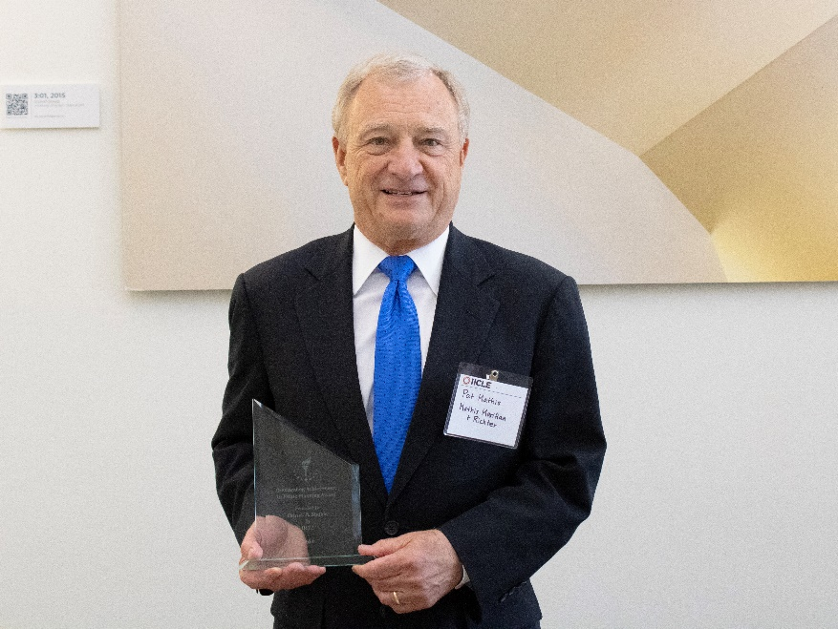
Patrick B. Mathis (MMR attorney) with the IICLE® Outstanding Achievement in Estate Planning Award.

-MMR-

Since 1984, Mathis, Marifian & Richter, Ltd. (MMR) has emerged as one of the most trusted and respected law firms in the St. Louis and Southern Illinois areas. The firm has offices in Belleville and Edwardsville, Illinois, as well as St. Louis, Missouri. MMR’s shareholders and associates possess knowledge and experience in practice areas that include business law, civil and commercial litigation, taxation, estate planning, banking law, and more. For more information, please visit www.mmrltd.com.
The Illinois Institute for Continuing Legal Education (IICLE®) is a 501(c)(3) not-for-profit organization that accomplishes its mission through the presentation of continuing legal education programs, the publication of comprehensive practice handbooks and forms, and the continued development and maintenance of additional legal resources designed to enhance Illinois law practice. For more information, please visit http://www.iicle.com or https://www.iicle.com/rising-star-award-nominations.

