BACK TO SCHOOL NIGHT

At Latzer Library

Tuesday, August 9, 2022

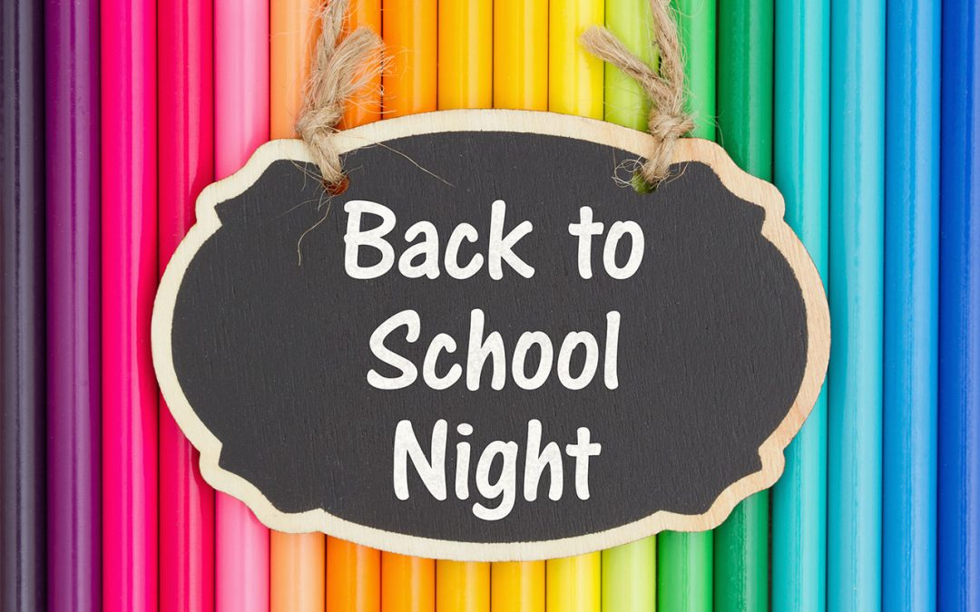

6 p.m.-7 p.m.

Featuring BABALOO MUSIC AND FUN

Designed for all school age children



Kick off the new school year on the right foot! Enjoy a great performance and check out some new books just in time for the new school year. Drawings for the door prizes will be awarded at the end of the performance.