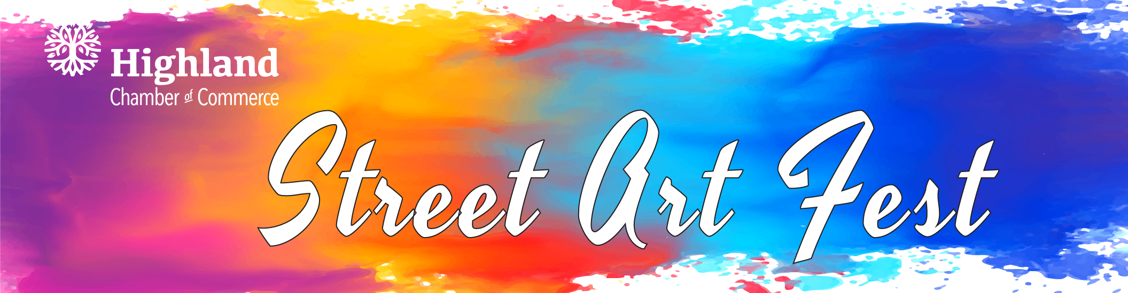
SEPTEMBER 21, 2024 ARTIST APPLICATION

*Lead Artist Name:
Address: City/State/Zip__________________________________
Cell Phone #: E-Mail:
Category Entry:
Professional (has a degree in or work experience in an art-related field or who produces and sells artwork)
Amateur 24+(no professional art training or work experience in an art-related field and who does not produce or sell artwork) Amateur 19-23 (no professional art training or work experience in an art-related field)
High School Student 14-18 (no professional art training or work experience in an art-related field)
____ Ms. Seller’s Class

Art Space Layout: Square Portrait Landscape
Background Color Preference: White Black None (blank pavement)
*When you arrive, your square will be painted in the layout and background color you requested and cannot be changed.

Art space dimensions are either 100 sq. ft., 65 sq. ft., and 40 sq. ft. and are dependent upon the sponsor’s level of commitment. Unless requested by a specific sponsor, artists are assigned by the committee. Artists will receive information on layout dimensions, sponsors and other details prior to the event.

ARTISTS PLEASE NOTE:
- All Artists must be signed in by 11 a.m. the day of event unless previous arrangements have been made with chamber staff. Failure to do so may result in another artist being assigned to your square. Artists must notify the chamber staff at 618-654-3721 within 48 hours if they cannot attend for ANY reason.
- No limits on extending beyond square limits. Please be respectful of your neighbor.
*****Artists will receive a FREE Street Art Fest T-shirt. (Limit of one free T-shirt per art space) Please circle your size (S/M/L/XL/XXL) & return this form no later than Aug 10th. We cannot guarantee a T-shirt to those who submit applications after this date.

*Artists are allowed one helper, however, the helper will not receive a t-shirt or swag bag.

Do you have/know of someone who would like to be your sponsor? If so, please provide their name and contact information below and we will send them a Sponsorship Form.

September 22nd is our rain date. We hope that you will plan to be available that date as well should the need arise. Please indicate here if you can commit to the Sept 22nd date: Yes OR No

The undersigned acknowledges and hereby releases the Street Art Festival/committee, Highland Chamber of Commerce, sponsors, City of Highland and their agents of any loss or damage to their person or property. All artwork must be appropriate for public viewing by all ages. No words or symbols intended as advertising may appear in the image. Please plan to sign your artwork at the bottom of the image area.
Photo Release: The Highland Chamber of Commerce would like to have all artists consent to the use of their image and images of their artwork for use on the Street Art Festival and Highland Chamber of Commerce websites, Facebook pages, press releases and promotional materials.
The below Artist’s signature consents to the unrestricted use of images, in connection with any use by the Highland Chamber of Commerce, City of Highland, and/or the Street Art Festival committee, including, but not limited to, any photographs of either the Artist or their Artwork or the use of their name in connection.

Signature ____________________________________ Date __________________

Highland Chamber of Commerce, 1216 Main St., Highland, IL 62249

